# COPE-COMPARE: Procurement data

**Trial ID:** WP4 _______

Retrieval Team:

* 41 Universitaire Ziekenhuizen Leuven, Belgium
* 42 Universitair Ziekenhuis Antwerpen, Belgium
* 43 Universitair Ziekenhuis Brussel, Belgium
* 44 Université Catholique de Louvain, Belgium
* 45 Université Libre de Bruxelles, Belgium
* 46 Centre Hospitalier de Liège, Belgium
* 47 Universitair Ziekenhuis Gent, Belgium
* 51 Universitair Medisch Centrum Groningen, Netherlands
* 52 Maastricht Universitair Centrum, Netherlands
* 53 Leids Universitair Centrum, Netherlands
* 54 Universitair Medisch Centrum Utrecht, Netherlands
* 55 Amsterdams Medisch Centrum, Netherlands
* 56 Universitair Medisch Centrum Nijmegen, Netherlands
* 57 Erasmus Medisch Centrum, Netherlands
* 58 VU Medisch Centrum, Netherlands

Donor ID: (ET n° or NHSBT n°)

Donor Age:

Donor Inclusion Criteria checked:

* DCD III > 50 years Yes No

Name of Transplant Technician:

Date and Time Phone Call Transplant Coordinator Received: ___/___/______ Time: ___:___

Name Transplant Coordinator:

Telephone Number Transplant Coordinator:

Hospital of Retrieval:

Scheduled Time of Withdrawal Therapy: ___/___/______ Time: ___:___

Arrival Time Technician at Hub: ___/___/______ Time: ___:___

Ice Boxes filled with sufficient amount of Ice (for Kidney Assist): ___/___/______ Time: ___:___

Departure from Hub: ___/___/______ Time: ___:___

Arrival at Donor Hospital: ___/___/______ Time: ___:___

## Donor Details:

Trial ID:

Date of Admission in Hospital: ___/___/______

Admitted to ITU: Yes No

If Yes, Date of Admission in ITU: ___/___/______

Date of procurement: ___/___/______

Gender: Female Male

Donor Weight (Kg):

Donor Height (cm):

Donor Ethnicity: Caucasian Black Other

Donor Blood Group: O A B AB

Other Organs procured:

* Lungs
* Pancreas
* Liver
* Tissue
* None

General Comments:

………………………………………………………………………………………………………………………………………………………………………………………………………………………………………………………………………………………………………………………………………………………………………………………………………………………………………………………………………………………

## Donor PreOp Data:

Donor Diagnosis:

* Trauma
* Cerebrovascular Accident
* Hypoxia
* Other: ……………………………………………………………………………………………………………………………………

Diabetes Mellitus: Yes No Unknown

Alcohol Abuse: Yes No Unknown

Cardiac Arrest (During ITU Stay prior to Retrieval Procedure): Yes No

Last Systolic Blood Pressure (Before Switch Off):

Last Diastolic Blood Pressure (Before Switch Off):

Diuresis last 24 Hrs (ml):

Diuresis last Hour (ml):

Dopamine: Yes No Unknown

Dobutamine: Yes No Unknown

(Nor)Adrenaline: Yes No Unknown

Vasopressine: Yes No Unknown

Other Medication Details:

………………………………………………………………………………………………………………………………………………………………………………………………………………………………………………………………………………………………………………………………………………………………………………………………………………………………………………………………………………………

General Comments:

………………………………………………………………………………………………………………………………………………………………………………………………………………………………………………………………………………………………………………………………………………………………………………………………………………………………………………………………………………………

## Donor Lab Results

Last Creatinine: mg/dl or µmol/L

Maximum Creatinine (during Admission): mg/dl or µmol/L

General Comments:

…………………………………………………………………………………………………………………………………………………………………………………………………………………………………………………………………………………………………………………………

## Donor Procedure:

Withdrawal of Life Support: ___/___/______ Time: ___:___

Systolic Arterial Pressure < 50 mm Hg (inadequate organ perfusion):

___/___/______ Time: ___:___

End of Cardiac Output (= Start No Touch Period): ___/___/______ Time: ___:___

Length of No Touch Period (minutes):

Diagnosis of Death: ___/___/______ Time: ___:___

Start In-Situ Cold Perfusion: ___/___/______ Time: ___:___

Systemic (aortic) Flush Solution Used:

* UW
* Marshall’s
* HTK
* Other: .............................................

Heparin administered to donor: Yes No

General Comments:

…………………………………………………………………………………………………………………………………………………………………………………………………………………………………………………………………………………………………………………………

## Kidney Inspection:

|  |  |
| --- | --- |
| **Left Kidney** | **Right Kidney** |
| Number of Renal Arteries: | Number of Renal Arteries: |
| Renal Graft Damage:   * Arterial Damage * Venous Damage * Ureteral Damage * Parenchymal Damage * None | Renal Graft Damage:   * Arterial Damage * Venous Damage * Ureteral Damage * Parenchymal Damage * None |
| Washout Perfusion:   * Homogenous * Patchy * Blue * Unknown | Washout Perfusion:   * Homogenous * Patchy * Blue * Unknown |
| Kidney Removal:  ___/___/______ Time: ___:___ | Kidney Removal:  ___/___/______ Time: ___:___ |
| Transplantable: Yes No | Transplantable: Yes No |
| General Comments:  ……………………………………………………………………..  ……………………………………………………………………..  ……………………………………………………………………..  …………………………………………………………………….. | General Comments:  ……………………………………………………………………..  ……………………………………………………………………..  ……………………………………………………………………..  …………………………………………………………………….. |

## Randomisation:

Kidney Transplantable (Left): Yes No

Kidney Transplantable (Right): Yes No

Confirmation Donor meets eligibility Criteria for inclusion:

* DCD III > 50 years: Yes No
* Both Kidneys Deemed Transplantable by Procurement Surgeon: Yes No
* both kidneys are allocated to a different recipient: Yes No Unknown

**If one question is answered with No, Do NOT randomise the kidney pair!**

**(REMARK: If recipients are not known at this time point, please go ahead with randomization)**

Left Kidney Randomized to: HMP HMPO2

Right Kidney Randomized to: HMP HMPO2

Trial ID Left Kidney: WP4 _____________L

Trial ID Right Kidney: WP4 _____________R

## Machine Perfusion:

|  |  |
| --- | --- |
| **Left Kidney** | **Right Kidney** |
| Machine Perfusion Possible: Yes No  If No, please provide details: ..………………………..  ……………………………………………………………………….  ……………………………………………………………………….  ………………………………………………………………………. | Machine Perfusion Possible: Yes No  If No, please provide details: ..………………………..  ……………………………………………………………………….  ……………………………………………………………………….  ………………………………………………………………………. |
| Start Machine Perfusion:  ___/___/______ Time: ___:___ | Start Machine Perfusion:  ___/___/______ Time: ___:___ |
| Used Patch Holder:   * Small * Large * Double Artery | Used Patch Holder:   * Small * Large * Double Artery |
| Artificial Patch Used: Yes No  If Yes, Please provide Details:   * Small * Large   Patch Number: 1 2 | Artificial Patch Used: Yes No  If Yes, Please provide Details:   * Small * Large   Patch Number: 1 2 |
| Is Oxygen Bottle Full: Yes No | Is Oxygen Bottle Full: Yes No |
| Oxygen Bottle Opened: Yes No | Oxygen Bottle Opened: Yes No |
| Oxygen Tank Changed: Yes No  If Yes, please provide Date and Time:  ___/___/______ Time: ___:___ | Oxygen Tank Changed: Yes No  If Yes, please provide Date and Time:  ___/___/______ Time: ___:___ |
| Ice Container Replenished: Yes No  If Yes, please provide Date and Time:  ___/___/______ Time: ___:___ | Ice Container Replenished: Yes No  If Yes, please provide Date and Time:  ___/___/______ Time: ___:___ |
| Logistically possible to measure pO2 perfusate (use blood gas analyser):  Yes No | Logistically possible to measure pO2 perfusate (use blood gas analyser):  Yes No |
| Value pO2: | Value pO2: |
| General Comments:  ……………………………………………………………………..  ……………………………………………………………………..  ……………………………………………………………………..  …………………………………………………………………….. | General Comments:  ……………………………………………………………………..  ……………………………………………………………………..  ……………………………………………………………………..  …………………………………………………………………….. |

## WP7 Sampling:

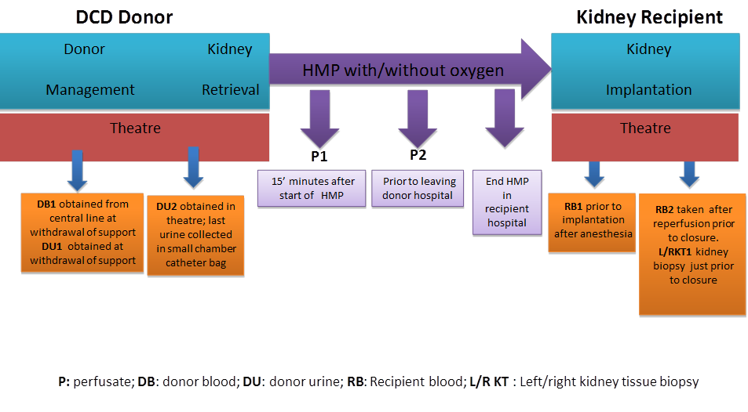

**P3**

Barcode COPE-box:

|  |  |  |  |
| --- | --- | --- | --- |
|  | **Barcode** | **Time taken** | **Time centrifugation** |
| **DB 1.1 EDTA** |  | ___/___/______ Time: ___:___ | ___/___/______ Time: ___:___ |
| **DB 1.2 SST** |  | ___/___/______ Time: ___:___ | ___/___/______ Time: ___:___ |
| **DU 1** |  | ___/___/______ Time: ___:___ | ___/___/______ Time: ___:___ |
| **DU 2** |  | ___/___/______ Time: ___:___ | ___/___/______ Time: ___:___ |
| **Left Kidney** |  |  |  |
| **LK P1** |  | ___/___/______ Time: ___:___ |  |
| **LK P2** |  | ___/___/______ Time: ___:___ |  |
| **Right Kidney** |  |  |  |
| **RK P1** |  | ___/___/______ Time: ___:___ |  |
| **RK P2** |  | ___/___/______ Time: ___:___ |  |

General Comments:

…………………………………………………………………………………………………………………………………………………………………………………………………………………………………………………………………………………………………………………………

…………………………………………………………………………………………………………………………………………………………………………………………………………………………………………………………………………………………………………………………

## Device Accountability:

### **Left Kidney:**

|  |  |  |
| --- | --- | --- |
| **Date Donor Procedure** |  | |
| **Trial ID** |  | |
| **DEVICE COMPONENTS** | | |
| **DEVICE** | **Lot number** | **Expiry Date** |
| Kidney Assist | Ref. n°  Serial n° |  |
| Disposables |  |  |
| Extra cannula small (3 mm) |  |  |
| Extra cannula large (5 mm) |  |  |
| Extra patch holder small |  |  |
| Extra patch holder large |  |  |
| Extra Double cannula set (incl, Kidney holder) |  |  |
| **PERFUSION SOLUTION** | | |
| **Perfusate solution** |  |  |

### **Right Kidney:**

|  |  |  |
| --- | --- | --- |
| **Date Donor Procedure** |  | |
| **Trial ID** |  | |
| **DEVICE COMPONENTS** | | |
| **DEVICE** | **Lot number** | **Expiry Date** |
| Kidney Assist | Ref. n°  Serial n° |  |
| Disposables |  |  |
| Extra cannula small (3 mm) |  |  |
| Extra cannula large (5 mm) |  |  |
| Extra patch holder small |  |  |
| Extra patch holder large |  |  |
| Extra Double cannula set (incl, Kidney holder) |  |  |
| **PERFUSION SOLUTION** | | |
| **Perfusate solution** |  |  |